**Lab 1. Designing and Implementing a VLSM Addressing Scheme**

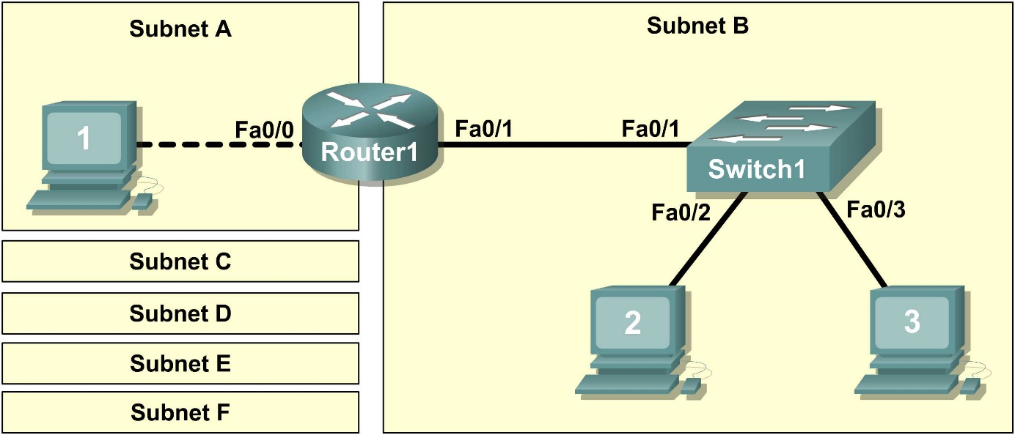

1. Scenario

In this lab, you will create a small network that requires connecting network devices and configuring host computers for basic network connectivity. SubnetA and SubnetB are subnets that are currently needed. SubnetC, SubnetD, SubnetE, and SubnetF are anticipated subnets, not yet connected to the network.

Task 1: Design the Logical Lab Topology.

Given an IP address and mask of **172.20.0.0 / 24** (address / mask), design an IP addressing scheme that satisfies the following requirements:

|  |  |
| --- | --- |
| **Subnet** | **Number of Hosts** |
| **SubnetA** | As shown in topology diagram |
| **SubnetB** | Between 80 – 100 |
| **SubnetC** | Between 40 – 52 |
| **SubnetD** | Between 20 – 29 |
| **SubnetE** | 12 |
| **SubnetF** | 5 |

Note: Always start with the subnet with the largest number of hosts and work your way down. Therefore, you should start with SubnetB and finish with SubnetA.

Step 1: Design SubnetB address block.

Begin the logical network design by satisfying the requirement of SubnetB, which requires the largest block of IP addresses. Using binary numbers to create your subnet chart, pick the first address block that will support SubnetB. Fill in the following table with IP address information for SubnetB:

|  |  |  |  |  |
| --- | --- | --- | --- | --- |
| **Network Address** | **Mask** | **First Host Address** | **Last Host Address** | **Broadcast** |
|  |  |  |  |  |

Step 2: Design SubnetC address block.

Satisfy the requirement of SubnetC, the next largest IP address block. Using binary numbers to create your subnet chart, pick the next available address block that will support SubnetC. Fill in the following table with IP address information for SubnetC:

|  |  |  |  |  |
| --- | --- | --- | --- | --- |
| **Network Address** | **Mask** | **First Host Address** | **Last Host Address** | **Broadcast** |
|  |  |  |  |  |

Step 3: Design SubnetD address block.

Satisfy the requirement of SubnetD, the next largest IP address block. Using binary numbers to create your subnet chart, pick the next available address block that will support SubnetD. Fill in the following table with IP address information for SubnetD:

|  |  |  |  |  |
| --- | --- | --- | --- | --- |
| **Network Address** | **Mask** | **First Host Address** | **Last Host Address** | **Broadcast** |
|  |  |  |  |  |

Step 4: Design SubnetE address block.

Satisfy the requirement of SubnetE, the next largest IP address block. Using binary numbers to create your subnet chart, pick the next available address block that will support SubnetE. Fill in the following table with IP address information for SubnetE:

|  |  |  |  |  |
| --- | --- | --- | --- | --- |
| **Network Address** | **Mask** | **First Host Address** | **Last Host Address** | **Broadcast** |
|  |  |  |  |  |

Step 5: Design SubnetF address block.

Satisfy the requirement of SubnetF, the next largest IP address block. Using binary numbers to create your subnet chart, pick the next available address block that will support SubnetF. Fill in the following table with IP address information for SubnetF:

|  |  |  |  |  |
| --- | --- | --- | --- | --- |
| **Network Address** | **Mask** | **First Host Address** | **Last Host Address** | **Broadcast** |
|  |  |  |  |  |

Step 6: Design SubnetA address block.

Satisfy the requirement of SubnetA, the smallest IP address block. Using binary numbers to create your subnet chart, pick the next available address block that will support SubnetA. Fill in the following table with IP address information for SubnetA:

|  |  |  |  |  |
| --- | --- | --- | --- | --- |
| **Network Address** | **Mask** | **First Host Address** | **Last Host Address** | **Broadcast** |
|  |  |  |  |  |

Task 2: Configure the Logical Topology.

Document logical network settings.

On SubnetA, Host1 will use the first IP address in the subnet. Router1, interface Fa0/0, will use the last host address. On SubnetB, host computers will use the first and second IP addresses in the subnet, respectively. Router1, interface Fa0/1, will use the last network host address.

To properly route Layer 2 frames between LAN devices, Switch1 does not require Layer 3 configuration. The IP address assigned to Switch 1, interface VLAN 1, is used to establish Layer 3 connectivity between external devices and the switch.

Write down the IP address information for each device:

|  |  |  |  |  |
| --- | --- | --- | --- | --- |
| **Device** | **Subnet** | **IP Address** | **Mask** | **Gateway** |
| Host1 |  |  |  |  |
| Router1-Fa0/0 |  |  |  |  |
| Host2 |  |  |  |  |
| Host3 |  |  |  |  |
| Switch1 |  |  |  |  |
| Router1-Fa0/1 |  |  |  |  |